Hamza Salahuddin
24k-3065
Lab-01
Task-01
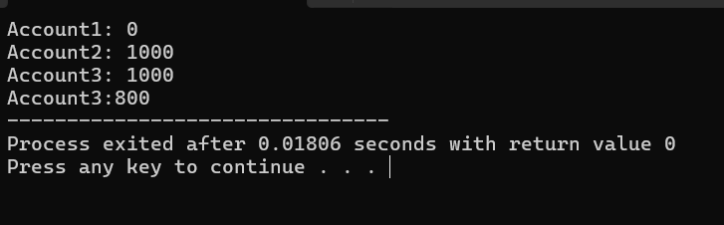
#include<iostream>
using namespace std;
class BankAccount{
public:
int balance;
BankAccount()
{
this->balance=0;
cout<<"Account1: "<<balance<<endl;
}
BankAccount(int balance)
{
this->balance=balance;
cout<<"Account2: "<<balance<<endl;
}
BankAccount(const BankAccount& other)
{
balance=other.balance;
cout<<"Account3: "<<balance<<endl;
}

};
int main(){0
BankAccount Obj1;
BankAccount Obj2(1000);
BankAccount Obj3= Obj2;
Obj3.balance-=200;
cout<<"Account3:"<< Obj3.balance;
return 0;
}
Task-02
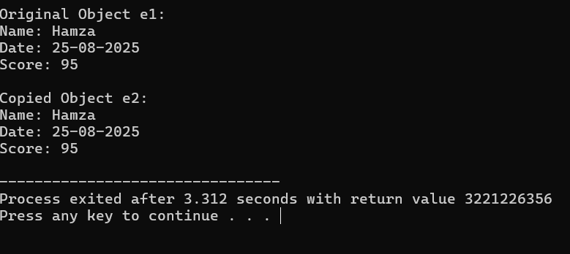
#include <iostream>
#include <cstring>
using namespace std;

class Exam {
char* name;
char* date;
int* score;

public:
Exam() {
name=NULL;
date=NULL;
score=NULL;
}

void setData(const char* n,const char* d,int s) {
name = new char[strlen(n) + 1];
strcpy(name, n);
date = new char[strlen(d) + 1];
strcpy(date, d);
score=new int;
*score=s;
}

void display() {
cout<<"Name: " <<name<<endl;
cout<<"Date: " <<date<<endl;
cout<<"Score: " <<*score<<endl;
}

~Exam() {
delete[] name;
delete[] date;
delete score;
}
};

int main() {
Exam e1;
e1.setData("Hamza","25-08-2025",95);
cout << "Original Object e1:"<<endl;
e1.display();
Exam e2 = e1;
cout << "\nCopied Object e2:"<<endl;
e2.display();

return 0;
}
Task-03
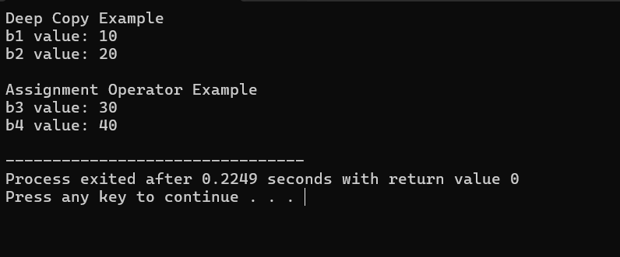
#include <iostream>
using namespace std;

class Box {
public:
int* value;
Box(int v = 0) {
value = new int;
*value = v;
}

~Box() {
delete value;
}

Box(const Box& other) {
value = new int;
*value = *other.value;
}

Box& operator=(const Box& other) {
if (this != &other) {
delete value;
value = new int;
*value = *other.value;
}
return *this;
}

void setValue(int v){
*value = v;
}
int getValue() const{
return *value;
}
};

int main() {
cout << "Deep Copy Example"<<endl;
Box b1(10);
Box b2 = b1;
b2.setValue(20);

cout << "b1 value: "<< b1.getValue()<< endl;
cout << "b2 value: "<< b2.getValue()<< endl;

cout << "\nAssignment Operator Example"<<endl;
Box b3(30);
Box b4;
b4 = b3;
b4.setValue(40);

cout<<"b3 value: "<<b3.getValue()<< endl;
cout<<"b4 value: "<<b4.getValue()<< endl;

return 0;
}
Task-06
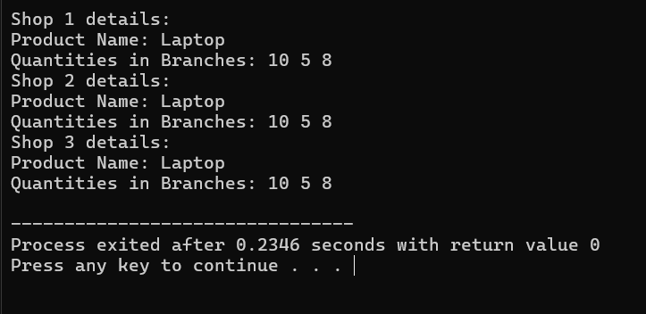

#include <iostream>
#include <cstring>
using namespace std;

class Shop {
public:
char* productName;
int* quantities;
int branches;

Shop(int n, const char* name) {
branches = n;
productName = new char[strlen(name) + 1];
strcpy(productName, name);
quantities = new int[branches];
for (int i = 0; i < branches; i++)
quantities[i] = 0;
}

Shop(const Shop& other) {
branches = other.branches;
productName = new char[strlen(other.productName) + 1];
strcpy(productName, other.productName);
quantities = new int[branches];
for (int i = 0; i < branches; i++)
quantities[i] = other.quantities[i];
}

Shop& operator=(const Shop& other) {
if (this != &other) {
delete[] productName;
delete[] quantities;
branches = other.branches;
productName = new char[strlen(other.productName) + 1];
strcpy(productName, other.productName);
quantities = new int[branches];
for (int i = 0; i < branches; i++)
quantities[i] = other.quantities[i];
}
return *this;
}

~Shop() {
delete[] productName;
delete[] quantities;
}

void setQuantity(int branchIndex, int qty) {
if (branchIndex >= 0 && branchIndex < branches)
quantities[branchIndex] = qty;
}

void display() {
cout<<"Product Name: "<<productName<<endl;
cout<<"Quantities in Branches: ";
for (int i = 0; i < branches; i++)
cout << quantities[i] << " ";
cout << endl;
}
};

int main() {
Shop shop1(3,"Laptop");
shop1.setQuantity(0, 10);
shop1.setQuantity(1, 5);
shop1.setQuantity(2, 8);

cout<<"Shop 1 details:"<<endl;
shop1.display();

Shop shop2 = shop1;
cout <<"Shop 2 details:"<<endl;
shop2.display();

Shop shop3(2,"Phone");
shop3 = shop1;
cout << "Shop 3 details:"<<endl;
shop3.display();

return 0;
}

